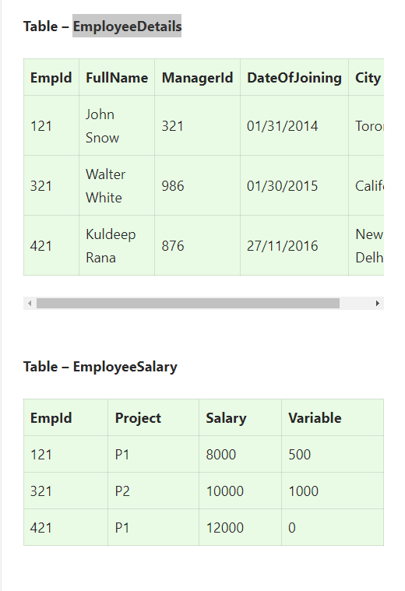

**Important queries**

**1.Write an SQL query to fetch the different projects available from the EmployeeSalary table.**

* **Select DISTINCT (project) from EmployeeSalary**

**Write an SQL query to fetch the count of employees working in project ‘P1’.**

* **Select count(emp_id) from employeesalary**

**Where project =” p1”**

**Write an SQL query to fetch those employees who live in Toronto and work under manager with ManagerId – 321**

* **select * from employeedet**

**Where city=”Toronoto” and managerid=”321”**

**Fetch all the employees who are not working on any project.**

* **select * from employeesalary**

**Where project IS NULL**

**Write an SQL query to fetch all those employees who work on Project other than P1.**

**-> select * from employeesalary**

**Where project NOT = ”p1”**

**Write an SQL query to fetch the employees whose name begins with any two characters, followed by a text “hn” and ending with any sequence of characters.**

* **select * from employeedet**

**Where fullname LIKE “__hn”**

**Write an SQL query to fetch all the EmpIds which are present in either of the tables – ‘EmployeeDetails’ and ‘EmployeeSalary’.**

* **Select emp_id from employeedetails**

**UNION**

**Select emp_id from employeesalary**

**Write an SQL query to fetch common records between two tables.**

* **Select emp_id from employeedetails**

**INTERSECT**

**Select emp_id from employeesalary**

**Write an SQL query to fetch records that are present in one table but not in another table.**

* **Select emp_id from employeedetails**

**UNION**

**Select emp_id from employeesalary**

Sub-query

**Write an SQL query to fetch the EmpIds that are present in both the tables –   ‘EmployeeDetails’ and ‘EmployeeSalary.**

* **Select empid from employeedet**
* **Where empid in**
* **Select empid from employeesalary**

**Write an SQL query to display both the EmpId and ManagerId together.**

**->** **SELECT CONCAT(EmpId, ManagerId) as NewId**

**FROM EmployeeDetails;**

**Write an SQL query to upper case the name of the employee and lower case the city values.**

**->**

**Write an SQL query to update the employee names by removing leading and trailing spaces.**

**->**

**Write an SQL query to fetch employee names having a salary greater than or equal to 5000 and less than or equal to 10000.**

* **Select fullname from employeedet**
* **Where empid IN**
* **(Select empid from employeesalary**
* **Where salary between 5000 and 10000);**

**Write an SQL query to fetch all the Employees details from EmployeeDetails table who joined in the Year 2020.**

* **select * from employeedetails**

**Where dateofjoining BETWEEN “2020/01/01’ AND ‘2020/12/31’**

**Write an SQL query to fetch all employee records from EmployeeDetails table who have a salary record in EmployeeSalary table.**

* **Select * from employeedetails E**
* **Where EXISTS**
* **(SELECT * FROM Employeesalary S)**
* **WHERE E.Empid=S.EMPid);**

**Write an SQL query to fetch project-wise count of employees sorted by project’s count in descending order.**

**->**

**Select project,count(empid) as empcount**

**From employeesalary**

**Group by project**

**Order by empcount desc**

**Join**

**write a query to fetch employee names and salary records. Display the employee details even if the salary record is not present for the employee.**

**->**

**Select e.fullname,s.salary from employee details e**

**Left join**

**Employeesalary s**

**On e.empid =s.empid**

**Ques.40. Write SQL query to find the 3rd highest salary from a table without using the TOP/limit keyword.**

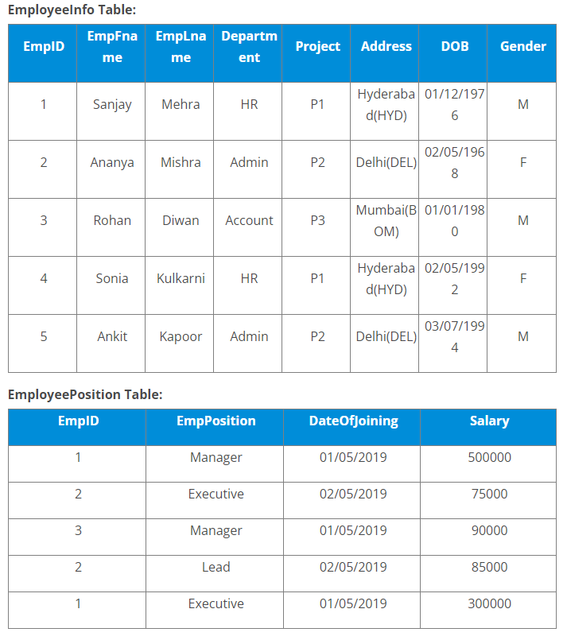

* [Write a query to fetch the EmpFname from the EmployeeInfo table in the upper case and use the ALIAS name as EmpName.](https://www.edureka.co/blog/interview-questions/sql-query-interview-questions#fetchname)

SELECT UPPER(EmpFname) AS EmpName FROM EmployeeInfo;

* [Write a query to fetch the number of employees working in the department ‘HR’.](https://www.edureka.co/blog/interview-questions/sql-query-interview-questions#fetchnumberofemployees)

SELECT COUNT(*) FROM EmployeeInfo WHERE Department = 'HR';

* [Write a query to retrieve the first four characters of  EmpLname from the EmployeeInfo table.](https://www.edureka.co/blog/interview-questions/sql-query-interview-questions#retrievecharacters)

SELECT SUBSTRING(EmpLname, 1, 4) FROM EmployeeInfo;

**Write a query to find the names of employees that begin with ‘S’**

SELECT * FROM EmployeeInfo WHERE EmpFname LIKE 'S%';

### ****Write a query to retrieve the EmpFname and EmpLname in a single column as “FullName”. The first name and the last name must be separated with space.****

### SELECT CONCAT(EmpFname, ' ', EmpLname) AS 'FullName' FROM EmployeeInfo;

### ****Write a query find number of employees whose DOB is between 02/05/1970 to 31/12/1975 and are grouped according to gender****

### SELECT COUNT(*), Gender FROM EmployeeInfo WHERE DOB BETWEEN '02/05/1970 ' AND '31/12/1975' GROUP BY Gender;

### ****Write a query to fetch all the records from the EmployeeInfo table ordered by EmpLname in descending order and Department in the ascending order.****

### SELECT * FROM EmployeeInfo ORDER BY EmpFname desc, Department asc;

### ****Write a query to fetch details of employees whose EmpLname ends with an alphabet ‘A’ and contains five alphabets.****

### SELECT * FROM EmployeeInfo WHERE EmpLname LIKE '____a';

### ****Write a query to fetch details of all employees excluding the employees with first names, “Sanjay” and “Sonia” from the EmployeeInfo table.****

### SELECT * FROM EmployeeInfo WHERE EmpFname NOT IN ('Sanjay','Sonia');

### ****Write a query to fetch details of employees with the address as “DELHI(DEL)****

### SELECT * FROM EmployeeInfo WHERE Address LIKE 'DELHI(DEL)%';

### Write a query to find the Nth highest salary from the table without using TOP/limit keyword.

SELECT Salary

FROM EmployeePosition E1

WHERE N-1 = (

      SELECT COUNT( DISTINCT ( E2.Salary ) )

      FROM EmployeePosition E2

      WHERE E2.Salary >  E1.Salary );

### ****Write a query to retrieve Departments who have less than 2 employees working in it.****

### SELECT DEPARTMENT, COUNT(EmpID) as 'EmpNo' FROM EmployeeInfo

### GROUP BY DEPARTMENT HAVING COUNT(EmpD) < 2;